Food Groups
The food we eat can be put into 5 main groups.
- The carbohydrates. These are the sugars and the starches. We get these by eating rice, potatoes, pasta and bread. Carbohydrates five our body the energy we need to live.
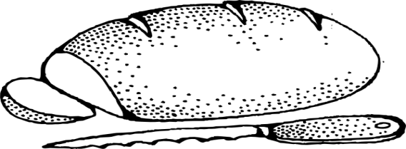
- The lipids. These are the fats and oils. We get these by eating dairy products like milk, butter and cheese. We also get them from some untrimmed meats. We also get them from nuts and some seeds. Our body needs lipids for energy storage, insulation, padding and making cell membranes.
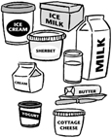
- The proteins. We get these form meat, peas, beans, nuts and dairy products. Our body needs proteins for growth and repair.
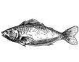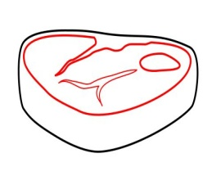
- Vitamins. These are complex chemicals. They include vitamin B and C. They are found in fruit, vegetables and meats. They are needed for special chemical reactions in the body and building some cell structures.
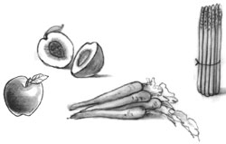
- Minerals. These are simple elements and compounds, like iron and phosphate. We get minerals by eating fruit, vegetables and meat. We need minerals to build structures in the cell and for strong bones and teeth.

Food Groups
Food group | Function (what you need them for) | Source (what you can eat to get some)
Carbohydrates

Lipids

Protein

Vitamins

Minerals

